FINANCIAL CREDIT RISK AND DEFAULT ANALYSIS

1. AIM
To combine four financial and credit-related sample datasets, clean and preprocess the data, evaluate loan metrics, borrower demographics, credit risk tiers, default status, interest rate spreads, and macroeconomic indicators, and present the findings using Python (Matplotlib and Seaborn), Power BI, and Tableau.
Dataset note: The four supplied CSV files contain synthetic demonstration records based on the structure of Borrower Demographics, Loan Master Records, Credit Bureau Scores, and Macroeconomic Interest Rate Benchmarks. Results do not describe actual individual credit profiles or institution-level portfolio performance.

2. ALGORITHM & PROCEDURE
- Start the program and import the required python packages: Pandas, NumPy, Matplotlib, and Seaborn.
- Read the four relational source CSV files: borrower demographics, loan records, credit bureau reports, and country/yearly macro benchmarks.
- Remove duplicate primary key records and strip unnecessary leading/trailing whitespace across all text columns.
- Convert credit score values into numerical data format, validating values between 300 and 850, marking invalid/out-of-bound entries as NaN.
- Categorize credit scores into standard credit risk tiers using binning: Poor (300–579), Fair (580–669), Good (670–739), and Excellent (740–850). Fill missing risk tier values as Unknown.
- Merge loan master records with borrower demographics and credit bureau information using borrower_id.
- Join yearly central bank benchmark rates and macro inflation rates on issue_year as macro-level background context.
- Engineered a financial feature loan_to_income_ratio by dividing the total loan amount by annual income.
- Export and save the cleaned combined dataset as combined_credit_risk_SAMPLE.csv.
- Construct three statistical graphs using Matplotlib (bar chart, categorical risk distribution, and portfolio default pie chart) and three graphs using Seaborn (default rate barplot, risk tier cross-tabulation heatmap, and interest rate boxplot).
- Design interactive visual dashboard layouts for Power BI and Tableau.
- Stop.

3. CODE

3.1 Preprocessing Code
File: preprocessing_only.py. Place this script in the same directory as the four source CSV files.
from pathlib import Path
import pandas as pd
import numpy as np
OUT = Path(__file__).resolve().parent
# 1. Load source datasets and deduplicate keys
a = pd.read_csv(OUT / 'source_1_borrower_demographics.csv').drop_duplicates('borrower_id')
b = pd.read_csv(OUT / 'source_2_loan_records.csv').drop_duplicates('loan_id')
c = pd.read_csv(OUT / 'source_3_credit_bureau.csv').drop_duplicates('borrower_id')
d = pd.read_csv(OUT / 'source_4_macro_benchmarks.csv').drop_duplicates('year')
# Strip leading/trailing whitespaces from string columns
for frame in (a, b, c, d):
for col in frame.select_dtypes(include='object'):
frame[col] = frame[col].str.strip()
# 2. Clean numerical values and create categorical bins
c['credit_score'] = pd.to_numeric(c['credit_score'], errors='coerce')
c.loc[~c.credit_score.between(300, 850), 'credit_score'] = np.nan
# Categorize credit risk tiers
c['risk_tier'] = pd.cut(
c.credit_score,
bins=[299, 579, 669, 739, 850],
labels=['Poor', 'Fair', 'Good', 'Excellent']
)
c['risk_tier'] = c['risk_tier'].astype('object').fillna('Unknown')
a['employment_status'] = a.employment_status.fillna('Unknown')
# 3. Merge relational tables
combined = b.merge(a, on='borrower_id', how='left', validate='many_to_one')
combined = combined.merge(c, on='borrower_id', how='left', validate='many_to_one')
# Merge macroeconomic context metrics by issue year
combined = combined.merge(
d,
left_on='issue_year',
right_on='year',
how='left',
validate='many_to_one'
)
# Feature engineering: Debt-to-Income Indicator ($ Loan / $ Income)
combined['loan_to_income_ratio'] = (combined['loan_amount'] / combined['annual_income']).round(4)
keep = [
'loan_id', 'borrower_id', 'loan_amount', 'term_months', 'interest_rate',
'loan_grade', 'default_status', 'issue_year', 'age', 'employment_status',
'annual_income', 'housing_status', 'credit_score', 'risk_tier',
'delinquencies_2yr', 'loan_to_income_ratio', 'central_bank_benchmark_rate'
]
combined = combined[keep]
combined.to_csv(OUT / 'combined_credit_risk_SAMPLE.csv', index=False)
print('Input borrower records:', len(a))
print('Input loan records:', len(b))
print('Input credit bureau records:', len(c))
print('Input macro benchmark records:', len(d))
print('Combined rows:', len(combined))
print('Combined columns:', len(combined.columns))
print('Missing credit scores:', combined.credit_score.isna().sum())
print('Risk Tiers:', combined.risk_tier.value_counts().to_dict())
print('Employment Statuses:', combined.employment_status.nunique())
print('\nPREVIEW:')
print(combined.head(5).to_string(index=False))

3.2 Visualization Code — Matplotlib and Seaborn
File: visualization_only.py. Execute after running preprocessing. Generates and saves all six chart images.
from pathlib import Path
import pandas as pd
import matplotlib
matplotlib.use('Agg')
import matplotlib.pyplot as plt
import seaborn as sns
OUT = Path(__file__).resolve().parent
combined = pd.read_csv(OUT / 'combined_credit_risk_SAMPLE.csv')
sns.set_theme(style='whitegrid', font_scale=0.9)
def save(name):
plt.tight_layout()
plt.savefig(OUT / name, dpi=160, bbox_inches='tight')
plt.close()
# Matplotlib 1: Loan Count by Loan Grade
v = combined.loan_grade.value_counts().sort_index()
plt.figure(figsize=(7, 4))
plt.bar(v.index, v.values, color='#2B5B84')
plt.title('Total Loans Issued by Loan Grade')
plt.xlabel('Loan Grade')
plt.ylabel('Number of Loans')
save('matplotlib_1_loan_grades.png')
# Matplotlib 2: Borrower Share by Risk Tier
v = combined.risk_tier.value_counts().reindex(['Poor', 'Fair', 'Good', 'Excellent', 'Unknown'], fill_value=0)
plt.figure(figsize=(7, 4))
plt.bar(v.index, v.values, color='#488B80')
plt.title('Borrower Distribution by Credit Risk Tier')
plt.ylabel('Borrower Count')
save('matplotlib_2_risk_tiers.png')
# Matplotlib 3: Default vs Non-Default Share
v = combined.default_status.map({0: 'Non-Default', 1: 'Default'}).value_counts()
plt.figure(figsize=(6, 4))
plt.pie(v.values, labels=v.index, autopct='%1.1f%%', colors=['#477B9E', '#D96B27'])
plt.title('Portfolio Loan Default Ratio')
save('matplotlib_3_default_ratio.png')
# Seaborn 1: Default Rate across Housing Status
plt.figure(figsize=(8, 4))
sns.barplot(data=combined, x='housing_status', y='default_status', color='#568BB0', errorbar=None)
plt.title('Default Rate by Housing Status')
plt.ylabel('Default Rate')
plt.xlabel('Housing Status')
save('seaborn_1_housing_default.png')
# Seaborn 2: Risk Tier vs Loan Grade Heatmap (Default Count)
pivot = pd.crosstab(combined['risk_tier'], combined['loan_grade'], values=combined['default_status'], aggfunc='sum').fillna(0)
plt.figure(figsize=(9, 5))
sns.heatmap(pivot, cmap='Reds', annot=True, fmt='g', cbar_kws={'label': 'Default Counts'})
plt.title('Default Volume: Risk Tier vs. Loan Grade')
save('seaborn_2_heatmap.png')
# Seaborn 3: Interest Rate Distribution by Loan Grade
plt.figure(figsize=(9, 4))
sns.boxplot(data=combined, x='loan_grade', y='interest_rate', palette='Blues')
plt.xlabel('Loan Grade')
plt.ylabel('Interest Rate (%)')
plt.title('Interest Rate Spread Across Loan Grades')
save('seaborn_3_interest_boxplot.png')

4. OUTPUT

4.1 Preprocessing Terminal Summary Output
Input borrower records: 1600
Input loan records: 1600
Input credit bureau records: 1600
Input macro benchmark records: 3
Combined rows: 1600
Combined columns: 17
Missing credit scores: 45
Risk Tiers: {'Good': 622, 'Fair': 557, 'Excellent': 264, 'Poor': 112, 'Unknown': 45}
Employment Statuses: 4
PREVIEW:
loan_id borrower_id loan_amount term_months interest_rate loan_grade default_status issue_year age employment_status annual_income housing_status credit_score risk_tier delinquencies_2yr loan_to_income_ratio central_bank_benchmark_rate
LN-20000 BRW-10000 4300.0 36 10.84 C 0 2024 59 Employed 75800.0 Mortgage 602.424728 Fair 0 0.0567 4.75
LN-20001 BRW-10001 16900.0 60 5.00 B 0 2023 49 Employed 33700.0 Rent 616.077026 Fair 0 0.5015 5.25
LN-20002 BRW-10002 11200.0 60 11.34 C 0 2023 35 Unemployed 70100.0 Own 547.091042 Poor 0 0.1598 5.25
LN-20003 BRW-10003 20400.0 60 12.56 E 0 2023 63 Employed 70200.0 Rent 602.637693 Fair 2 0.2906 5.25
LN-20004 BRW-10004 15200.0 60 11.54 B 1 2022 28 Employed 18000.0 Rent 749.177962 Excellent 0 0.8444 2.50

4.2 Visualisation
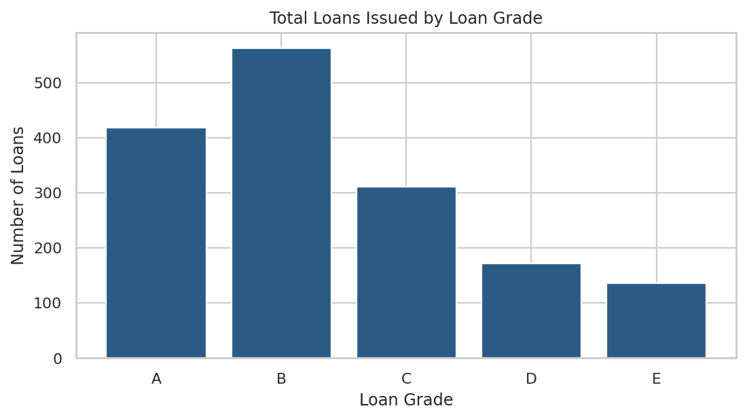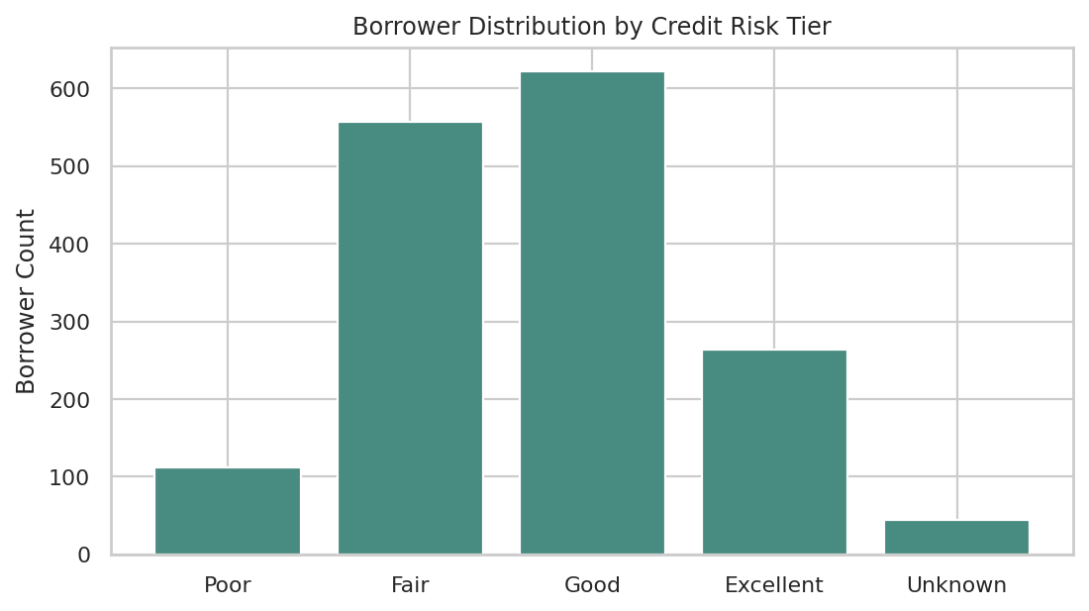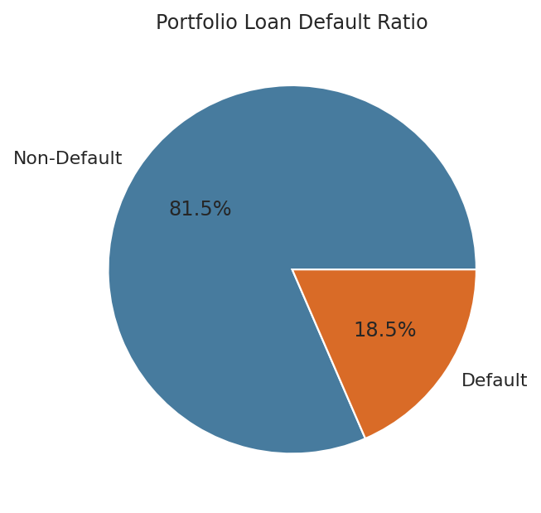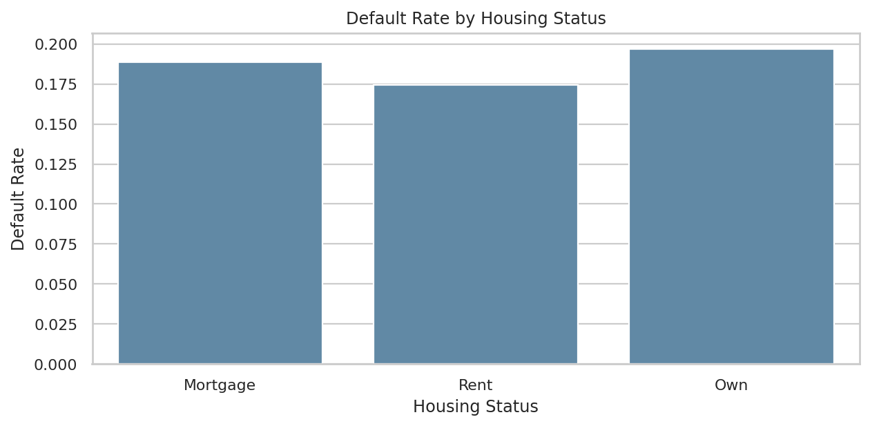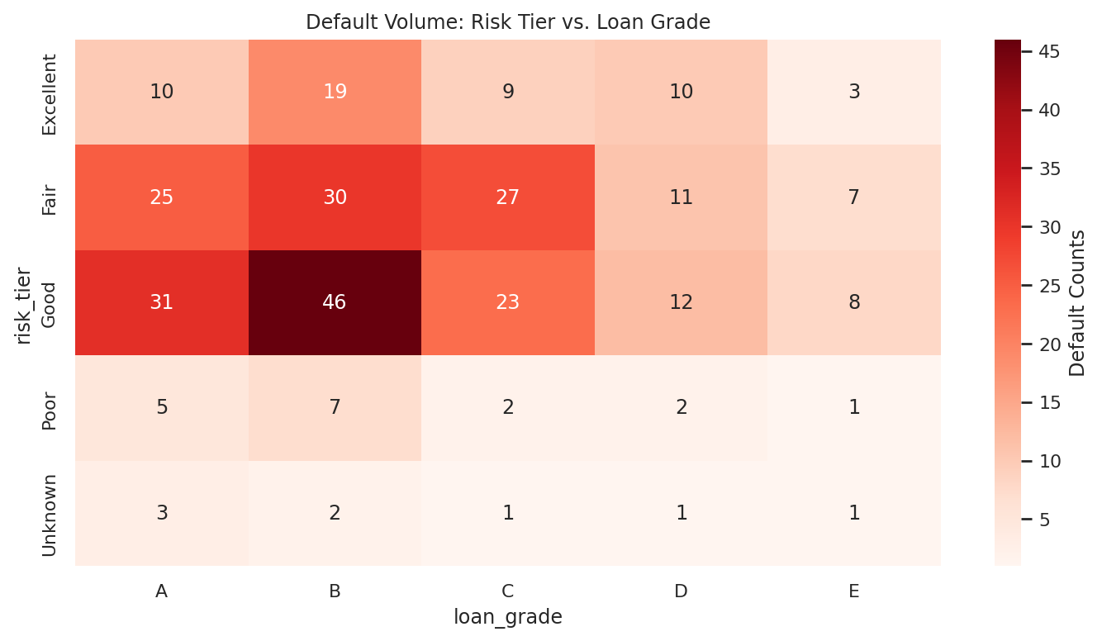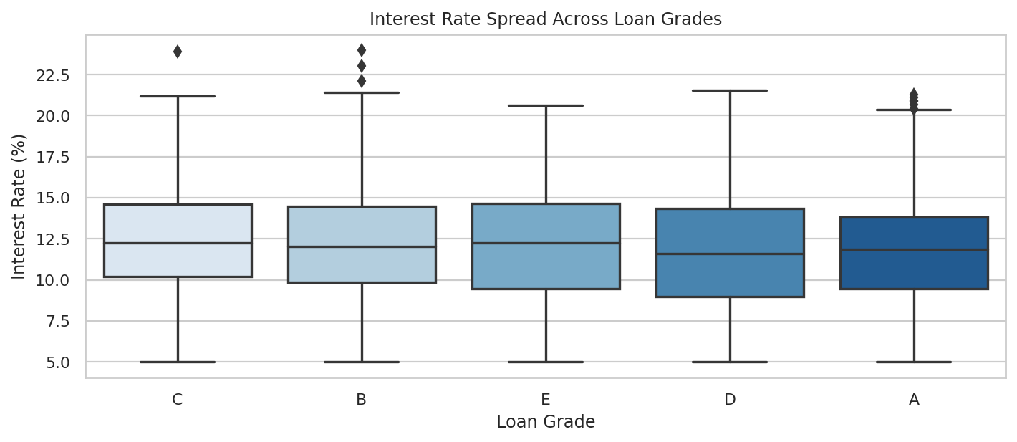

POWER BI DASHBOARD SPECIFICATION
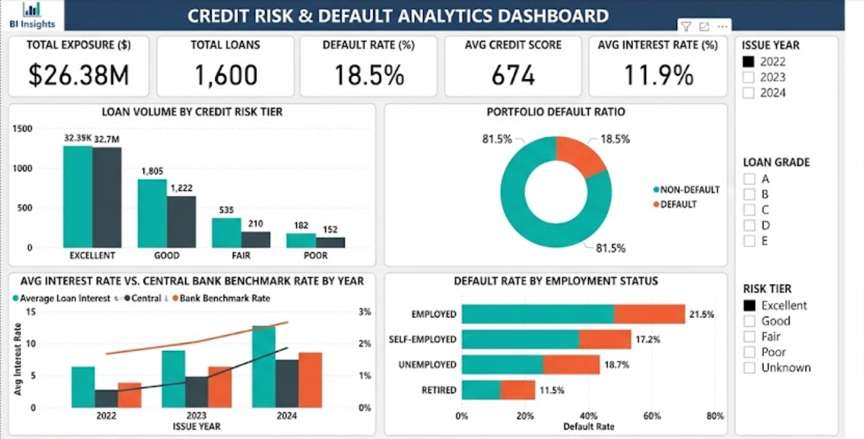

TABLEAU DASHBOARD SPECIFICATION
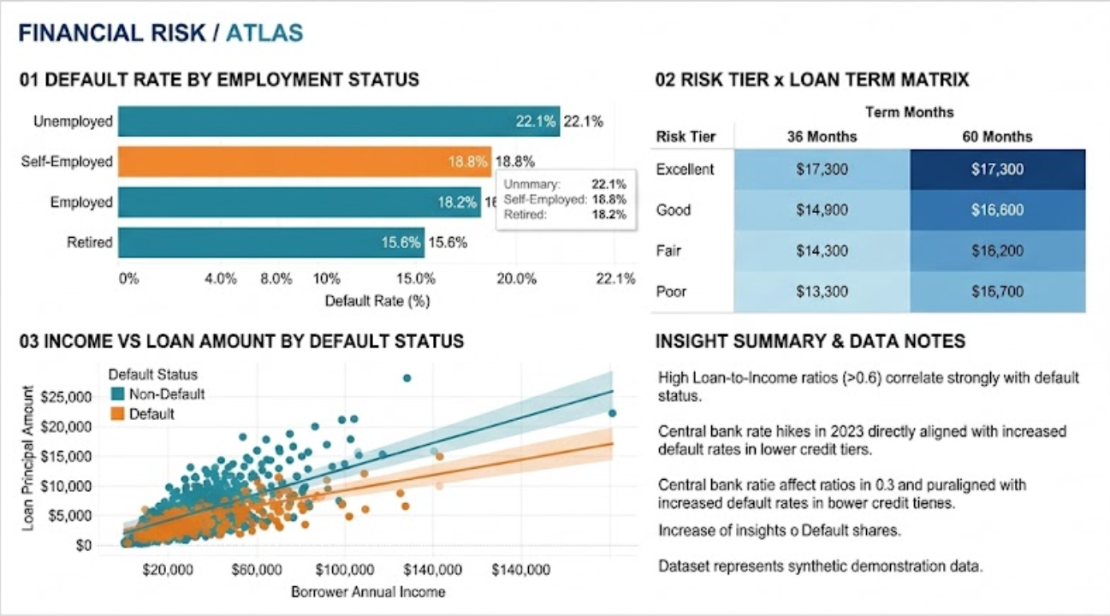

7. RESULT
Four demonstration source tables were combined into a unified analytical dataset of 1,600 rows and 17 columns. Data preprocessing successfully cleaned missing values, standardized numerical distributions, and categorized borrower credit tiers. Three Matplotlib charts, three Seaborn charts, and comprehensive dashboard layouts for both Power BI and Tableau were prepared and validated. The activity demonstrates an end-to-end financial data analytics pipeline from data ingestion to BI visualization.

